TASK ON RDS
- Create MariaDB DB on EC2.
- Launched an EC2 instance
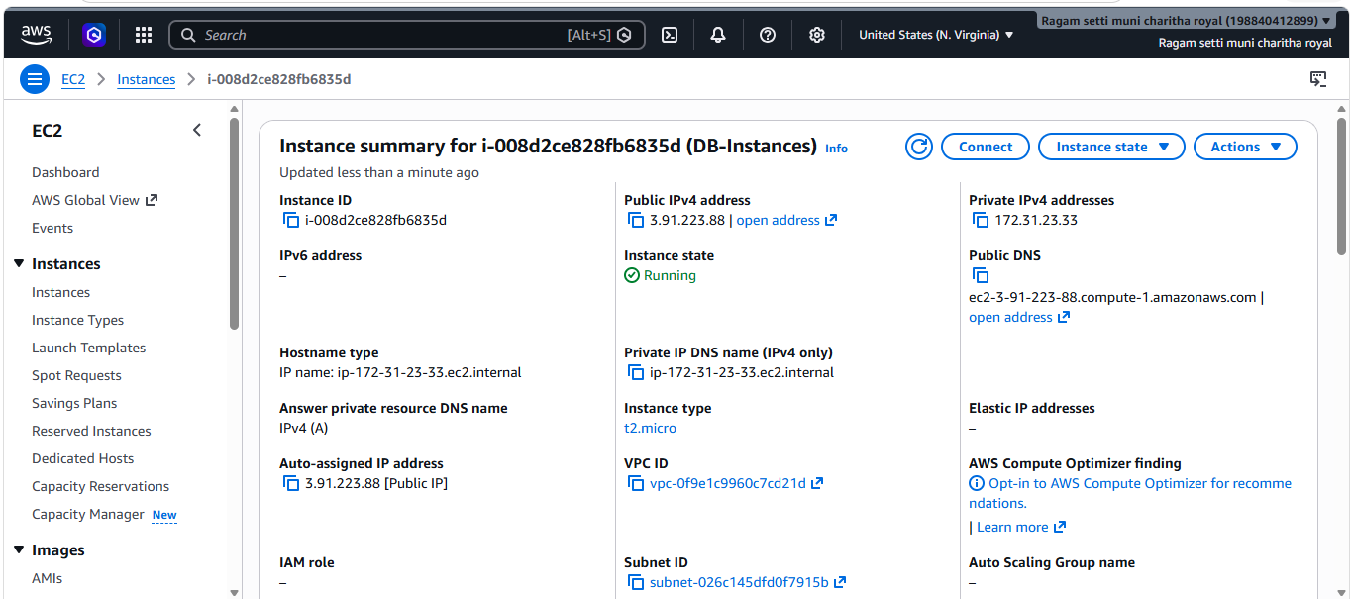
- Connected to the EC2 instance and updated all packages on the instance using Sudo yum update -y
- Installed MariaDB server using Sudo yum install mariadb105-server -y.
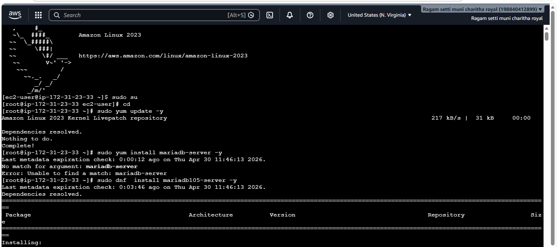
- Started MariaDB service and enabled it at boot using systemctl start mariadb and systemctl enable MariaDB.
- Verified MariaDB service is running using systemctl status MariaDB.
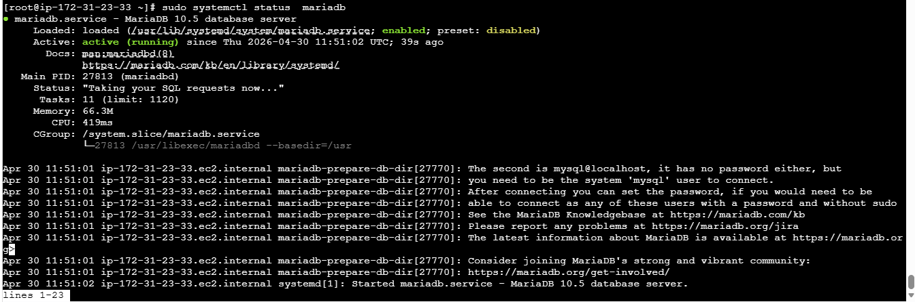
- Insert some dummy data.
- Set environment variables, logged into MariaDB using root credentials, and selected the database using USE ec2db;.
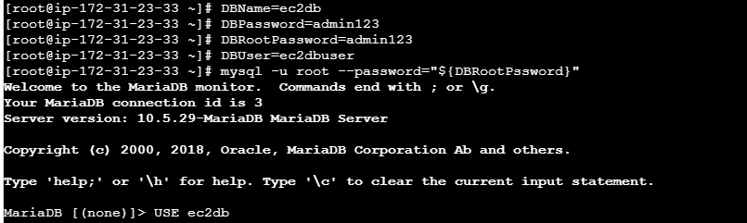
- Created database and user with privileges using a setup script, executed it in MariaDB, and removed the temporary script file.
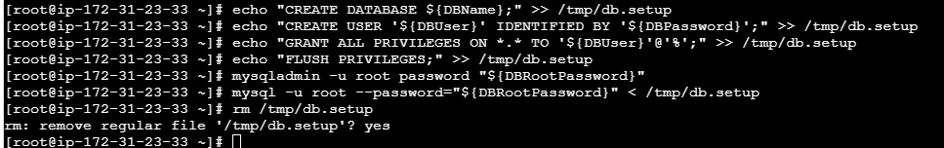
- Created a table, inserted dummy records into it, and verified the data using a SELECT query.
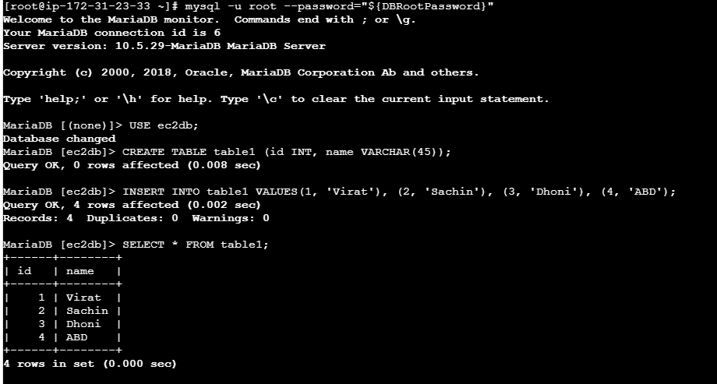
- Take the backup of dummy data on EC2.
- Took a backup of the MariaDB database using mysqldump and verified the backup file creation in the EC2 instance.
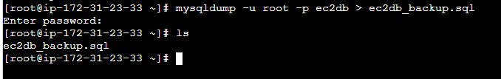
- Launch MariaDB RDS instance.
- Navigated to RDS dashboard and clicked on Create database option to start creating a new database instance.
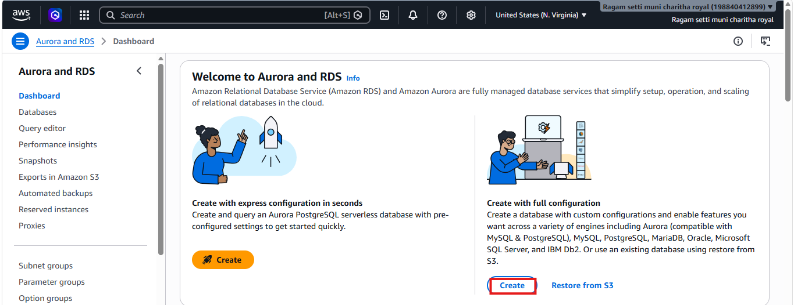
- Selected MariaDB engine and chose Easy create option while creating the RDS database instance.
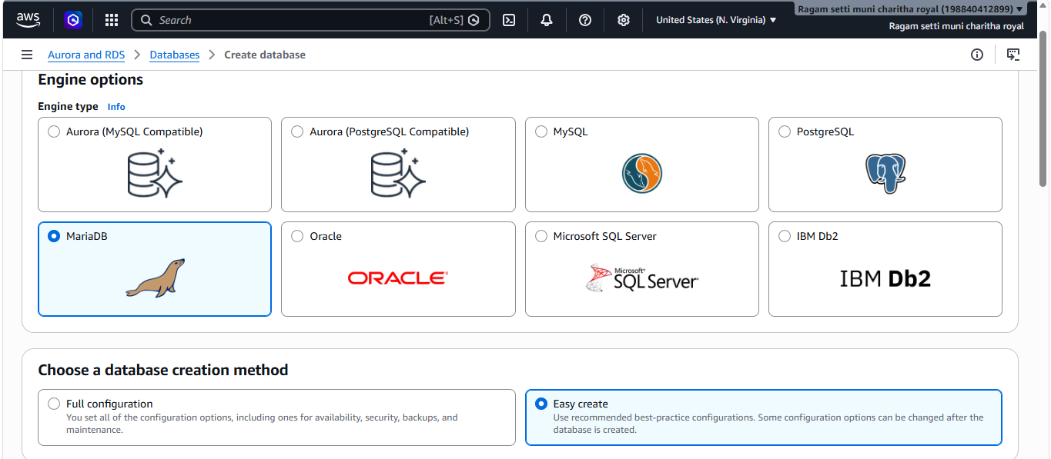
- Selected Free tier (db.t4g.micro), provided DB instance identifier and master username while configuring the RDS MariaDB instance.
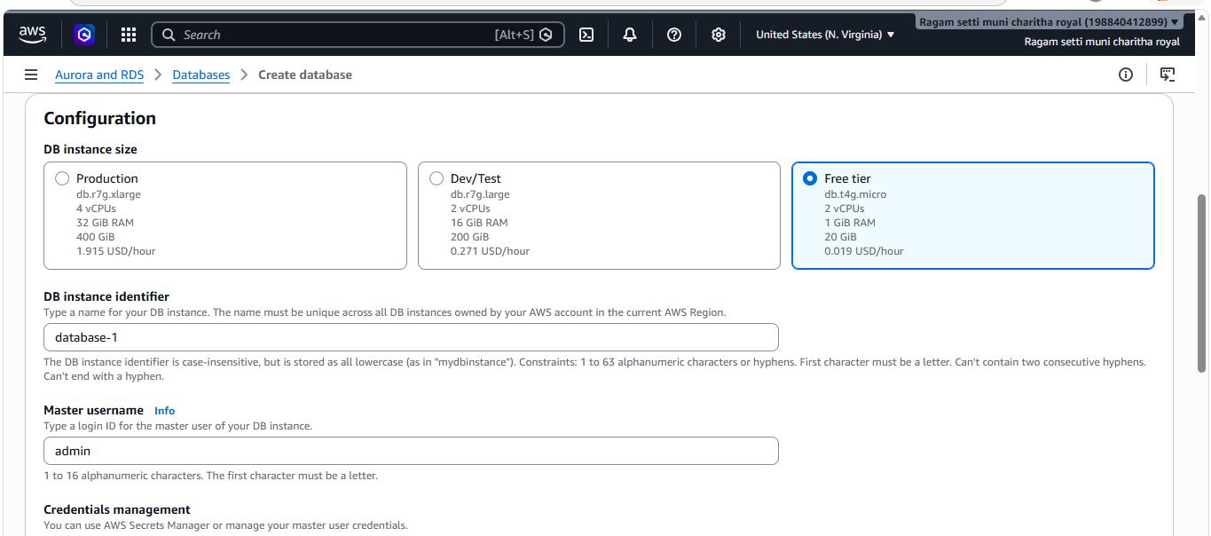
- Successfully initiated the creation of the MariaDB RDS instance and verified that the database status is in creating state.
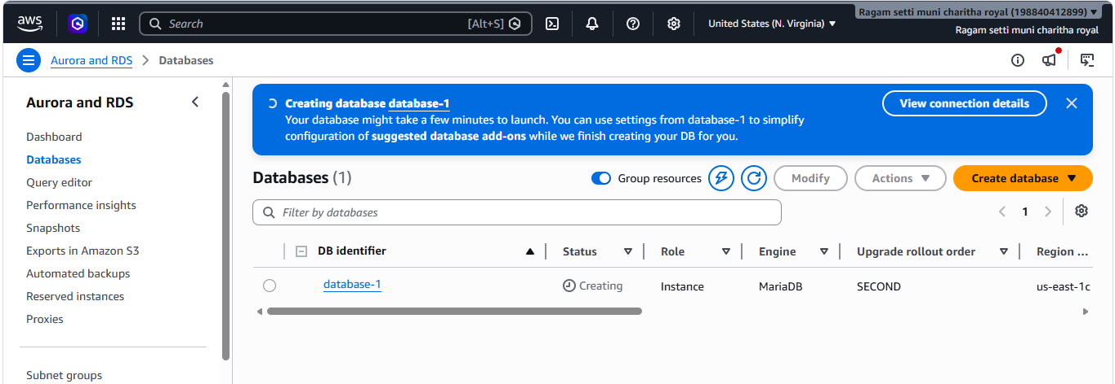
- Database is now available.
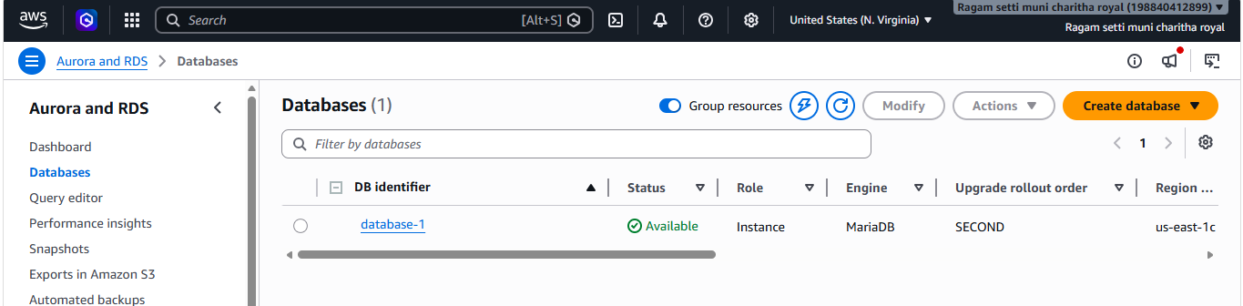
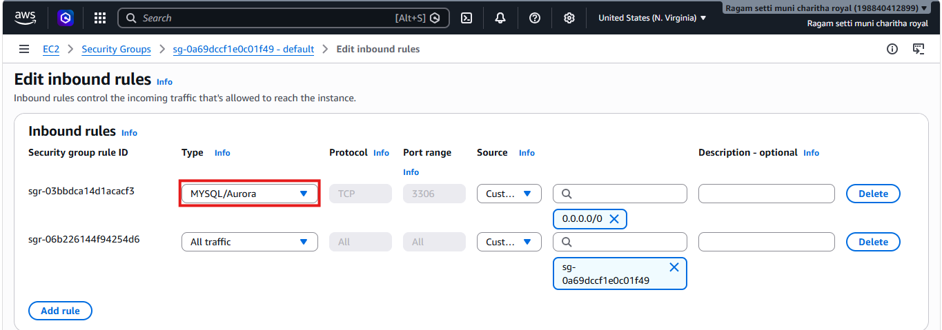
- Connected to the MariaDB RDS instance from EC2 and verified the available default databases using SHOW DATABASES;.
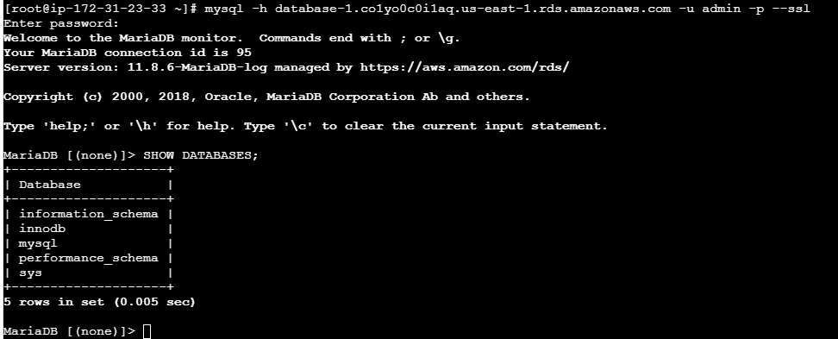
- Migrate database from EC2 to RDS.
- Connected to the MariaDB RDS instance using SSL, created a new database, and verified successful execution.
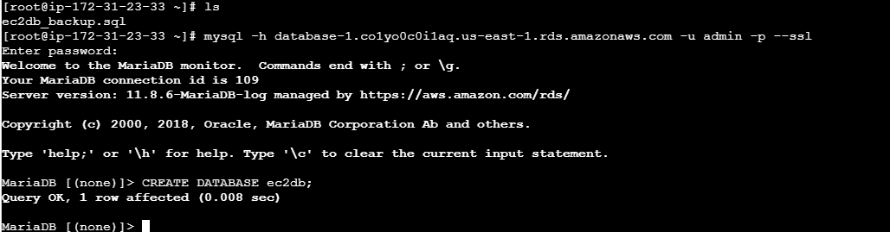
- Successfully migrated the database from EC2 to RDS using a backup file and verified the data by querying the table.
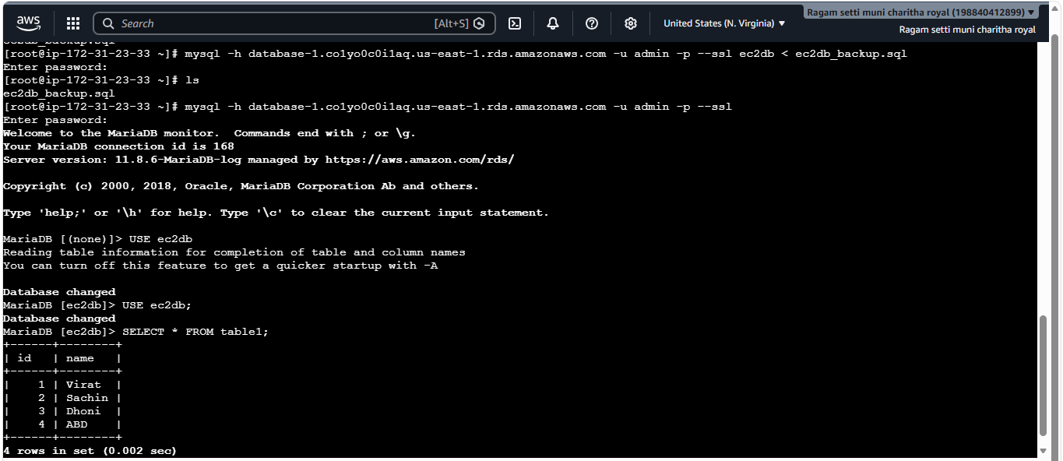
- Install MySQL DB on EC2.
- Ran sudo dnf update -y on the EC2 instance and confirmed the system is up to date.
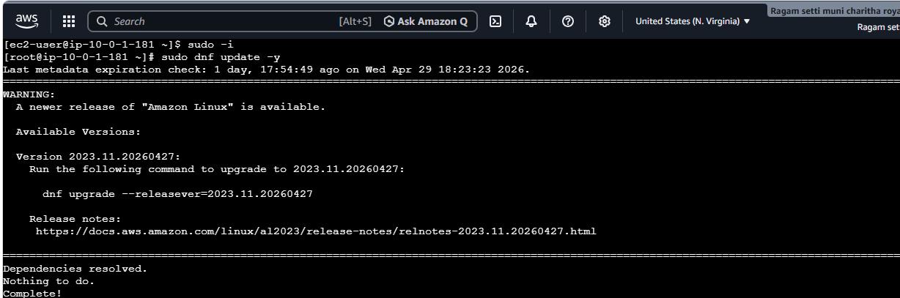
- Installed MySQL Community repository on Amazon Linux 2023 using the MySQL official RPM package successfully.
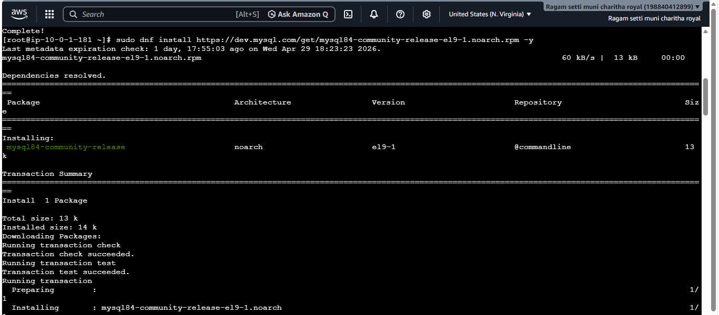
- Installed MySQL Community Server and its required dependencies successfully on Amazon Linux 2023 using the MySQL repository.
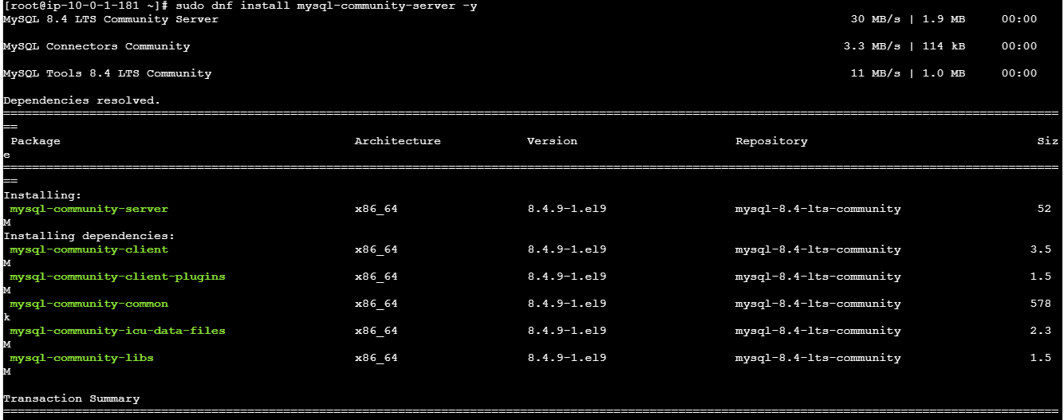
- Started and enabled MySQL service, retrieved the temporary root password, and successfully logged into MySQL after resolving access issues.
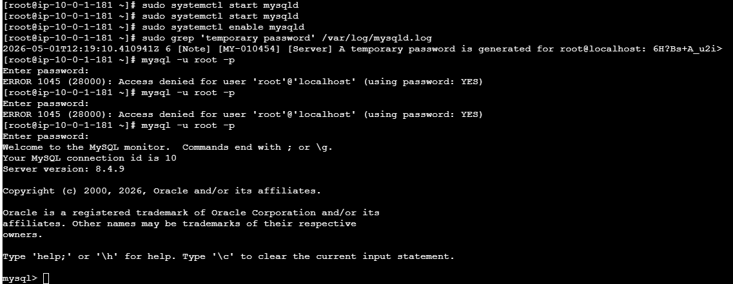
- Launch MySQL RDS image.
- Successfully launched a MySQL RDS instance and verified its availability in AWS.
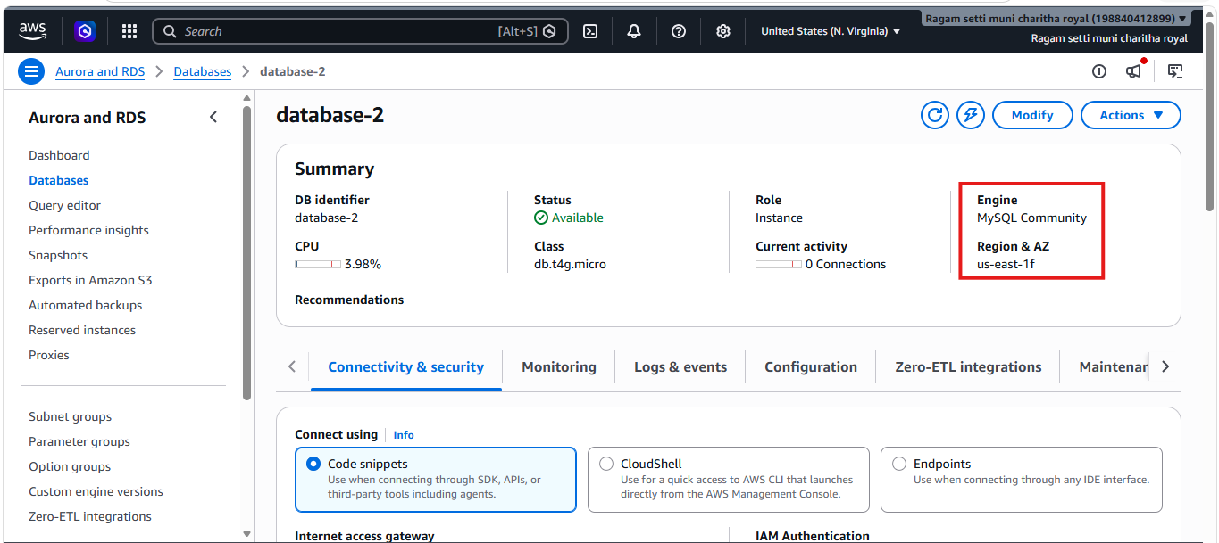
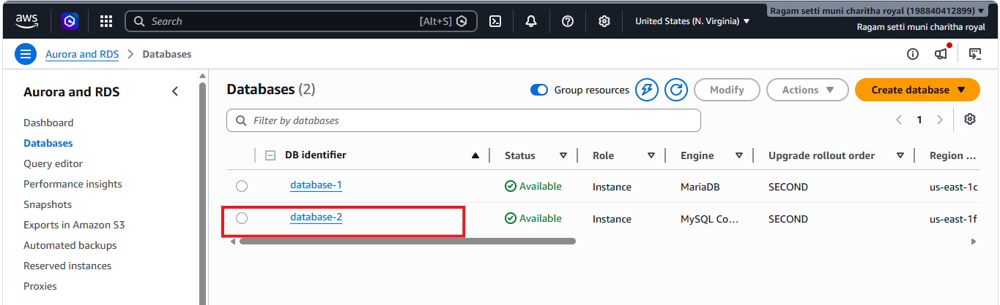
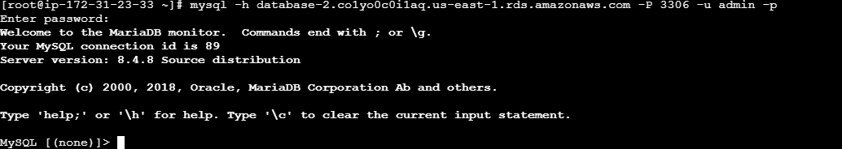
8.Configure Multi-AZ.
- Modified the RDS MySQL instance and enabled Multi-AZ deployment under availability settings. 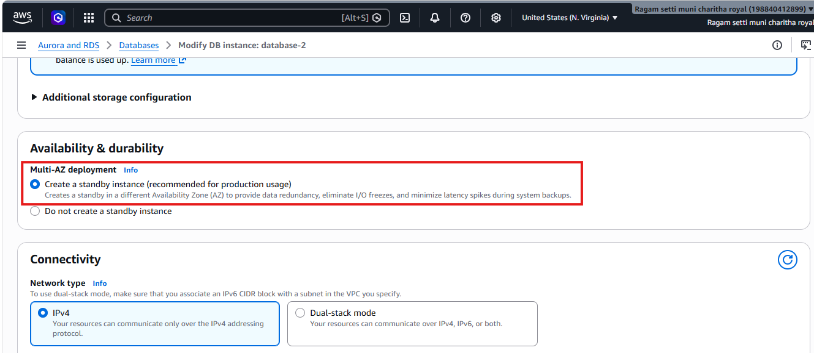
- Applied changes immediately and verified that the instance status is available with Multi-AZ enabled.
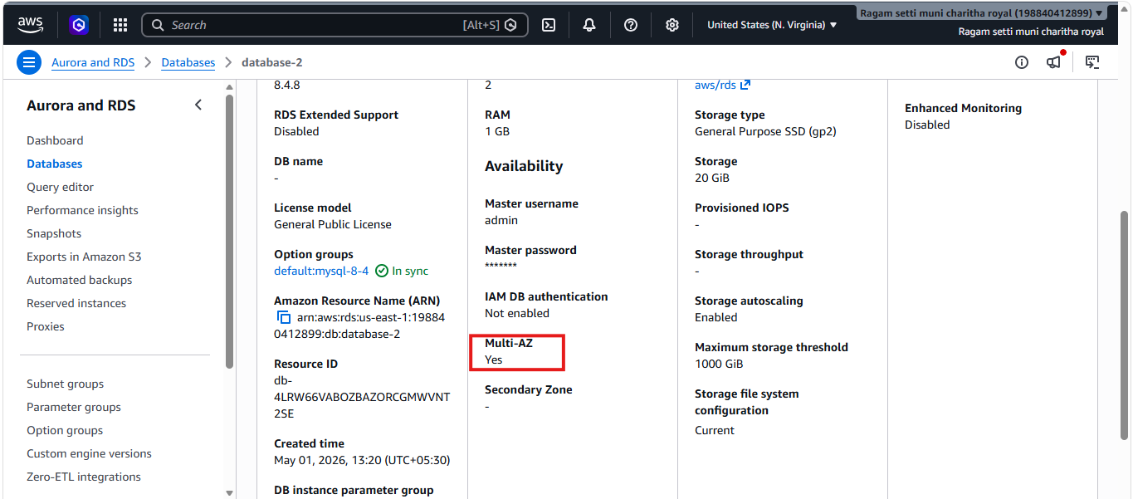
9.Take backup of DB and restore the DB.
- Taken a snapshot from mysql datatabase-1 it created a snapshot successfully for database1
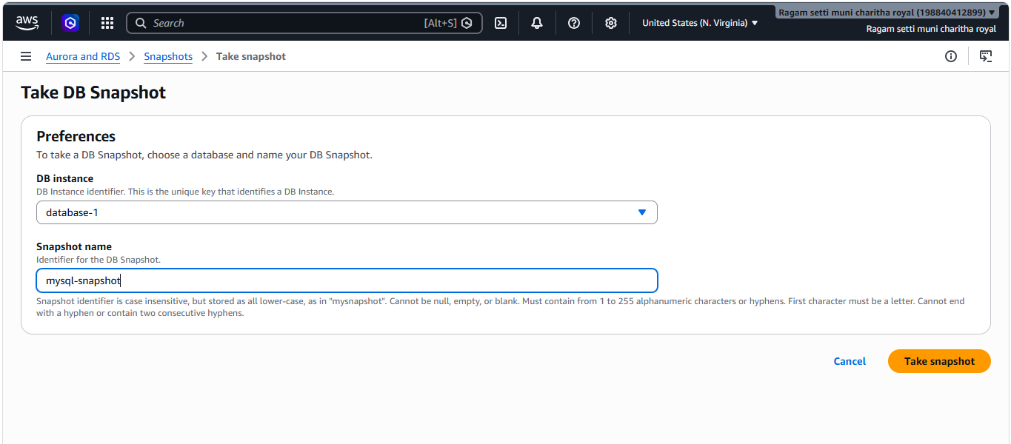
- Now restore the snapshot
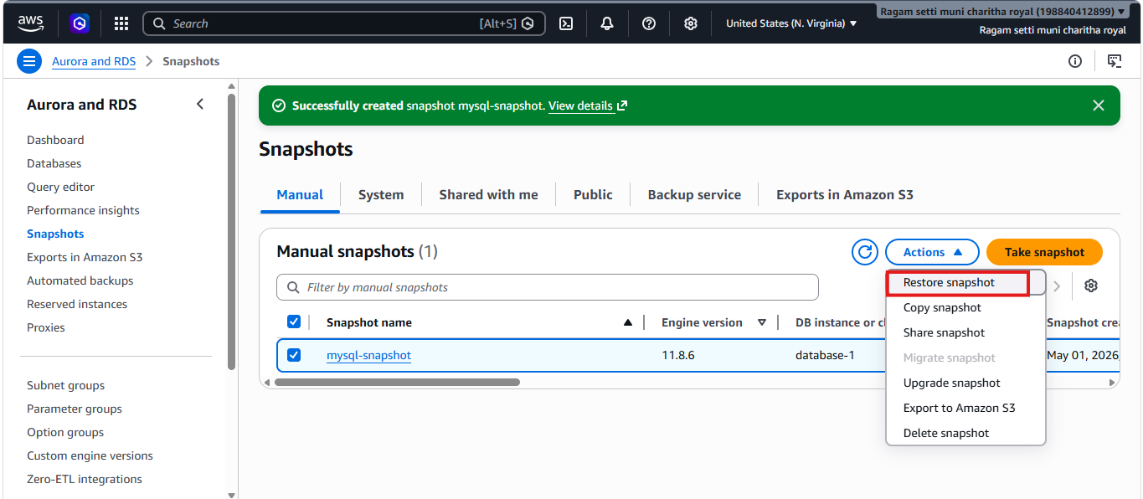
- Restored the snapshot database of mysql
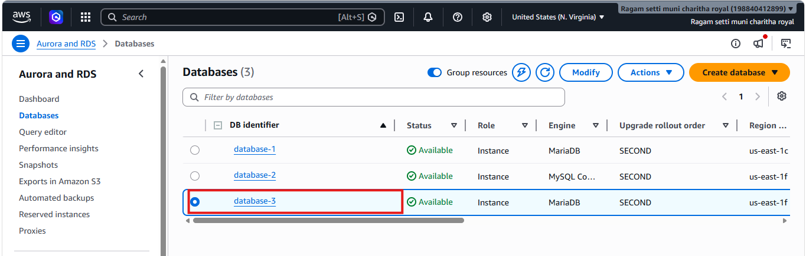
- Snapshot was created and restored to a new RDS instance to simulate recovery
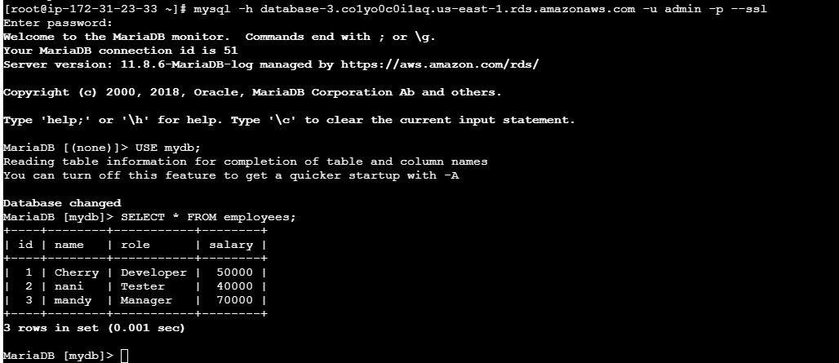
10.Create read replica.
- Open database and select database and in actions click replica
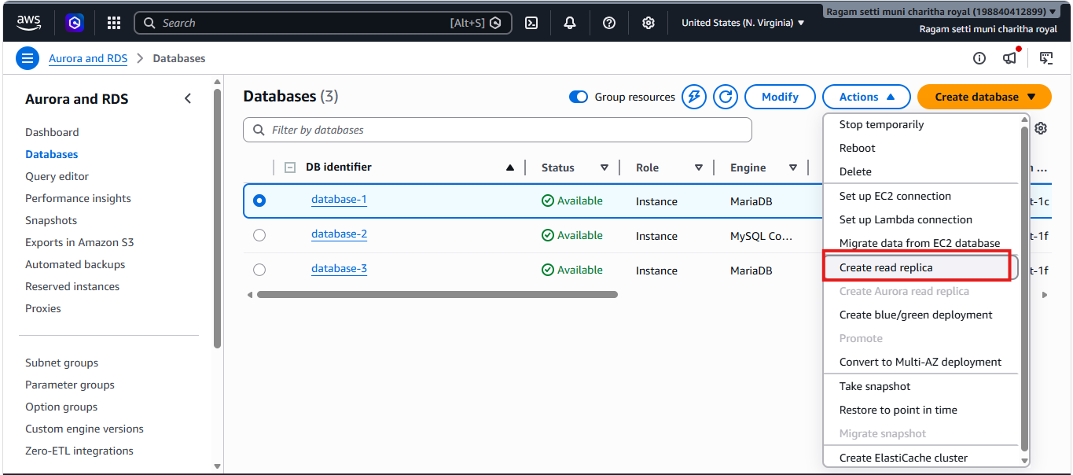
- Created replica in database-1
